PRACTICAL 9

Title : Study of Rational Test Manager along with Rational Administrator

Aim : To know functions and features of Testing Tool Rational Test Manager

Procedure:

1)  Open Sample Software Under Test and know detail functionality of  Classic A ( Album Purchase Software )

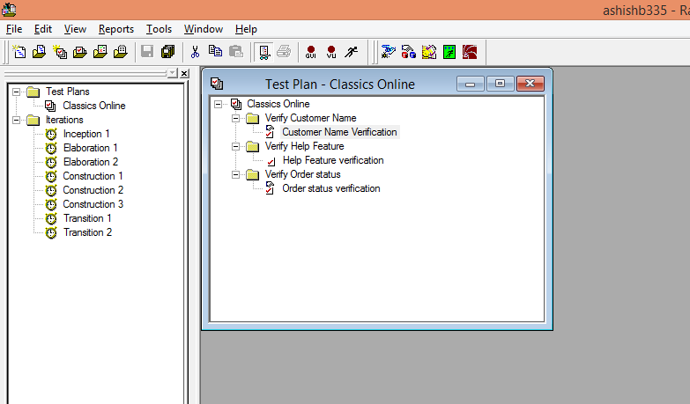

  2)  Create Testing Project with Rational Administrator

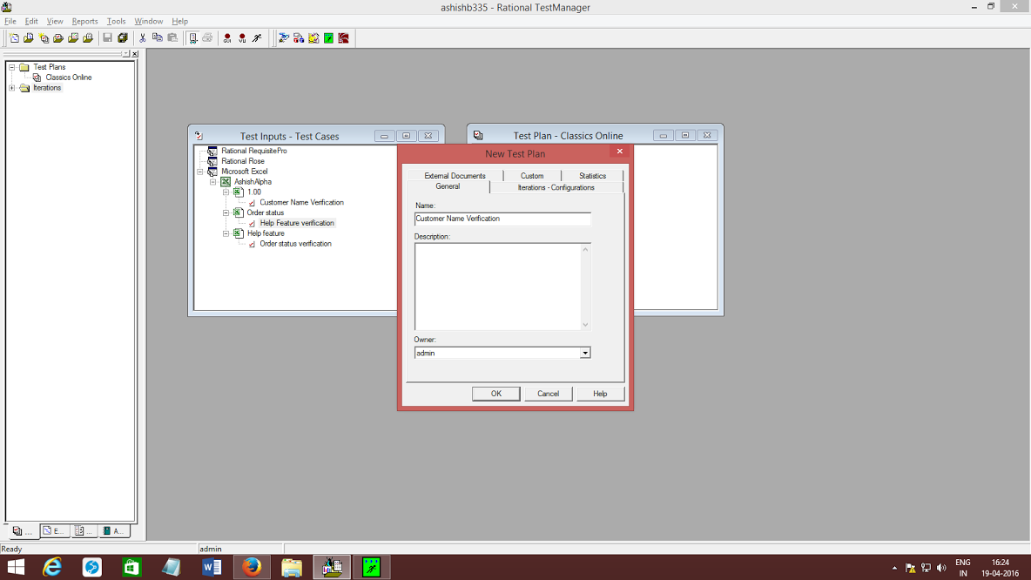

3)  Write  Five Test Cases for Classic A (With given Format )

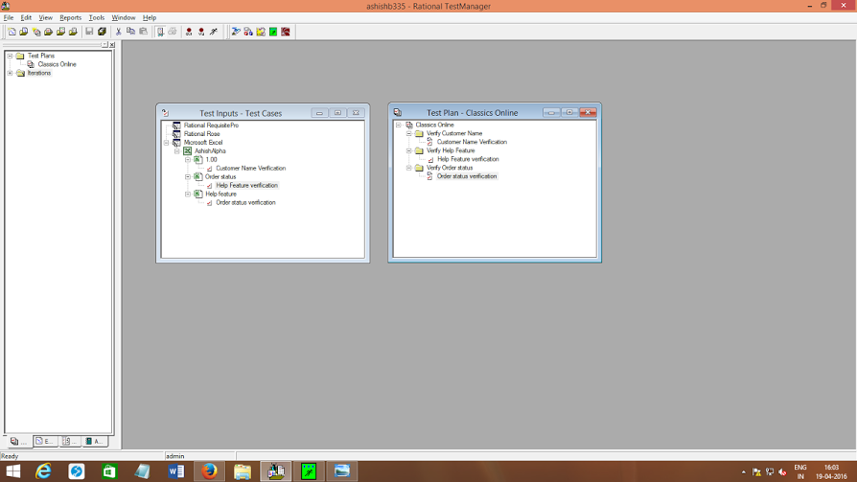

4)  Execute Five Test Cases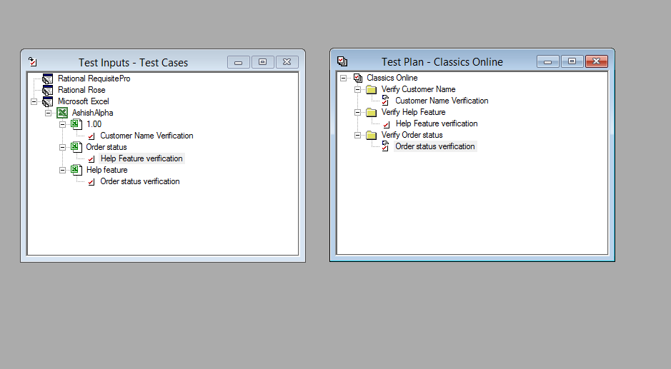

5) Prepare Test Report

